Environmental Purchasing
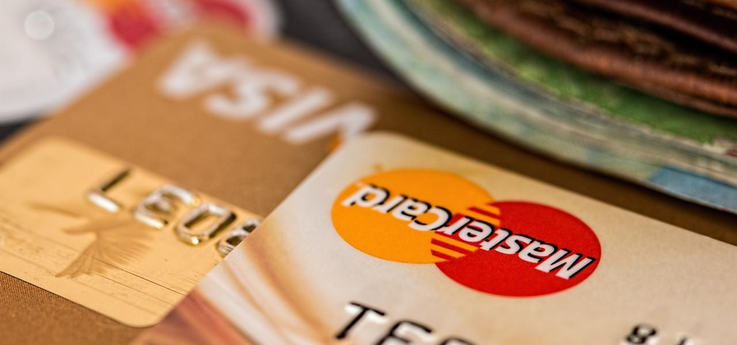
A Guide by Pet Sustainability Coalition

Executive Summary
Sustainable purchasing is one of the most powerful levers pet industry companies can leverage to reduce environmental impact, reinforce brand reputation, and navigate regulatory expectations. This Executive Summary provides a high-level overview of why sustainable procurement matters—and how to operationalize it effectively.

Business Benefits
- Cost Savings: Sustainable purchasing can reduce waste management and energy costs, and mitigate future regulatory fees.
- Risk Reduction: Avoid the pitfalls of greenwashing by emphasizing certifications and traceable supply chains.
- Brand Value: Meeting sustainability expectations boosts customer loyalty, enhances brand equity, and aligns with modern consumer values.

Why It Matters
- Consumer priorities: Approximately 70% of pet owners say it’s important that the pet products they purchase are environmentally friendly or sustainable PetExec.
- Willingness to pay more: Over half (51%) of pet owners are willing to pay more for ethical or sustainable pet care products Pet Food Processing.
- Global concern and engagement: In a global survey by Euromonitor International, 65% of pet owners expressed concern about climate change and were more inclined toward “green” activities compared to non-pet owners Parker Freeze Dry.
- Packaging expectations: As of early 2025, nearly 70% of U.S. pet owners preferred buying from brands that demonstrate a commitment to sustainability—especially in packaging (e.g., recyclable, compostable, biodegradable, refillable) DC Pet Distribution.

What to Prioritize
- Certified materials: Look for trustworthy credentials such as FSC, Fair Trade, USDA Organic, Recycled Claim Standard, RSPO, or B Corp.
- Circular Design: Favor packaging and products that are refillable, reusable, recyclable, or compostable.
- Local Sourcing: Shorter supply chains reduce carbon footprints and enhance resilience.
- Transparency & Measurement: Require suppliers to share verified sustainability data—ideally including Scope 3 emissions.
- Track Key Performance Indicators (KPIs)
Example metrics:
  - Percentage of purchases with sustainability certifications
  - Percentage of suppliers with active sustainability programs
  - Percentage of locally sourced products
  - Measurable reductions in packaging footprint or product carbon impact

How to Use This Guide
This guide supports your organization in adopting sustainable purchasing practices while maintaining financial and performance standards. It provides:
- Key environmental considerations for commonly used materials
- Vendor evaluation criteria, including certifications and traceability
- Employee education on core sustainability concepts
The purchasing policies are organized into seven key material categories. Each category highlights criteria in order of environmental benefit, starting with the most impactful. Where cost or performance constraints arise, exceptions may be necessary, but preference should always be given to products that combine environmental, social, and financial value.
This guide also emphasizes:
- Third-party certifications to avoid greenwashing
- Scope 3 emissions tracking to capture supply chain impacts
- Supplier transparency and innovation to foster continual improvement

Definition of Terms
Included at the bottom of each material purchasing guideline is a list of commonly used sustainability terms and their definitions. These terms will likely come up in conversations with vendors about environmental guidelines.

Environmental Purchasing Policy
[YOUR COMPANY NAME] is committed to embedding sustainability across all operations, including procurement. Sustainable purchasing considers not only cost but also material inputs, production methods, transportation impacts, product use, and end-of-life outcomes.
Our goals are to purchase products and services that:
- Conserve natural resources and reduce waste
- Lower energy use and greenhouse gas emissions
- Minimize toxicity and hazardous substances
- Contain recycled or reclaimed content
- Are recyclable, reusable, repairable, or refillable
- Carry credible sustainability certifications (e.g., FSC, USDA Organic, Fair Trade, Recycled Claim Standard, RSPO, B Corp)
- Support circular economy principles and innovation (e.g., refill systems, biodegradable alternatives)
- Are responsibly sourced, including locally and domestically when possible
We prioritize working with suppliers who share this commitment and can provide transparency through verifiable claims, certifications, or supplier audits.
Metrics we track may include:
- % of total purchases with sustainability certifications
- % of suppliers with CSR or sustainability programs
- % of local/domestic sourcing
- Carbon footprint reductions of purchased goods

Importance of Sustainable Purchasing
Sustainable purchasing shifts spending away from goods and services that harm people and the planet, toward those that deliver positive environmental, social, and financial outcomes.
Why it matters in the pet industry:
- Consumer demand: 85% of pet owners consider sustainability important in product choice; nearly half are willing to pay more for verifiably sustainable products.
- Market growth: Sales of pet products in recyclable, compostable, or biobased packaging have grown more than 400% in recent years.
- Retail expectations: Major retailers now require sustainability data from suppliers, including packaging and emissions metrics.
Key Benefits:
- Bottom line: Save through energy, water, and waste reductions; avoid future carbon and waste fees; capture competitive advantage and market share.
- Risk reduction: Stay ahead of regulations; reduce liability from toxic materials; avoid reputational risks tied to greenwashing.
- Brand image: Meet rising customer expectations; strengthen stakeholder trust; enhance employee engagement and community health.

Sustainability Benefits of Sustainable Purchasing
- Conserves natural resources
- Reduces energy use and greenhouse gas emissions
- Avoids waste generation
- Improves efficiency in raw material use
- Reduces or eliminates toxic emissions
- Supports suppliers with strong sustainability commitments
- Provides safer, healthier products for pets and people
- Improves worker health and supply chain conditions
- Expands markets for sustainable products

General Purchasing Guide
Sustainable procurement goes beyond product substitutions—it requires a systems approach to design, sourcing, and use.
Questions to ask before purchasing:
- Do we truly need this product, or can we reduce overall use?
- Can the product be smaller, lighter, refillable, reusable, or repairable?
- Is it designed for durability and multifunctionality?
- Does it contain recycled, reclaimed, or certified sustainable content?
- Is the packaging recyclable, compostable, or refillable?
- Can it be sourced locally to reduce transport emissions?
- Does it rely on renewable resources or innovative materials?
- Has the supplier provided transparent data (e.g., life-cycle assessment, Scope 3 emissions, or sustainability reports)?

Key to Material Purchasing Guides
- Priorities: List the most important first
- Exceptions: Take priority over policies
- An Empty circle indicates a low or no positive impact
- Half Circle indicates a medium positive impact
- Full Circle indicates a high positive impact
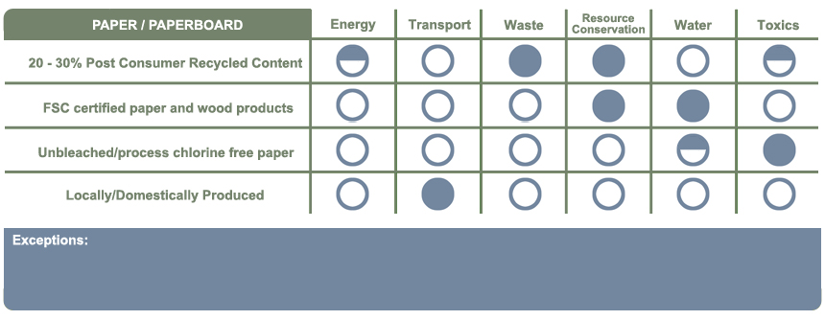
Paper / Paperboard Purchasing Guide

1. The environmentally-preferred product is not available at a competitive price
2. The environmentally-preferred product is not available within a reasonable time frame
3. The environmentally-preferred product does not meet appropriate performance standards
Definition of Terms
- Post-Consumer Recycled Content Paper contains fiber that has been used in paper products before and has been recycled into new paper. It is considered the most environmentally friendly since it has been used at least once before.
- Recycled Content paper contains recycled paper from pre and postindustrial sources, including scraps, wood chips, and sometimes virgin paper.
- Forest Stewardship Council (FSC) Certified Paper and Wood Products are guaranteed to have been logged from forests in a sustainably managed process where no old growth forests were cut down.
- Unbleached/Process Chlorine Free Paper ensures no chlorine or chlorine compounds were used in the pulp, papermaking or recycling processes.
- Locally/Domestically Produced paper has been manufactured locally or domestically and has come from forests that have been logged domestically, ensuring reduced transportation impacts.

1. The environmentally-preferred product is not available at a competitive price
2. The environmentally-preferred product is not available within a reasonable time frame
3. The environmentally-preferred product does not meet appropriate performance standards
Cotton Purchasing Guide
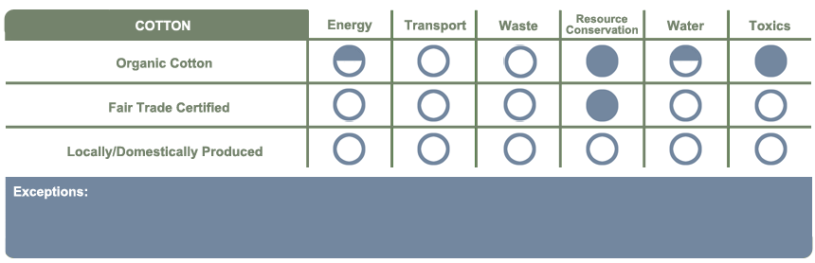

1. The environmentally-preferred product is not available at a competitive price
2. The environmentally-preferred product is not available within a reasonable time frame
3. The environmentally-preferred product does not meet appropriate performance standards

Definition of Terms
- Organic Cotton is grown without the use of toxic herbicides and fertilizers, using methods and materials that have a lower impact on the environment than conventional cotton.
- Fair Trade Certified means the cotton has met specific environmental, labor, and developmental standards throughout the sourcing and production of the material.
- Locally/Domestically Produced cotton has been manufactured locally or domestically and has come from fields that have been grown and harvested domestically, ensuring reduced transportation impacts.

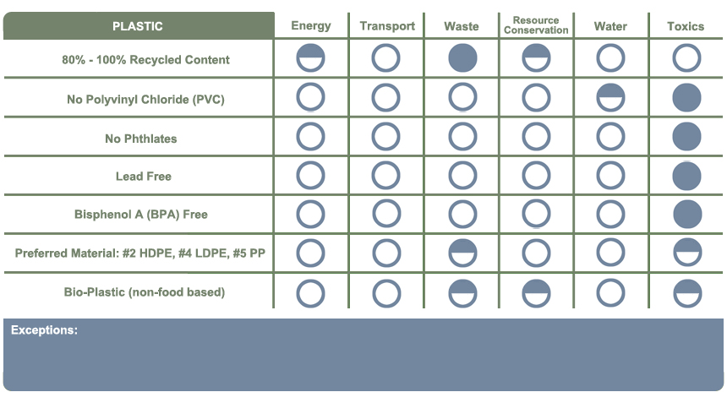
Plastic Purchasing Guide

1. The environmentally-preferred product is not available at a competitive price
2. The environmentally-preferred product is not available within a reasonable time frame
3. The environmentally-preferred product does not meet appropriate performance standards
3. The environmentally-preferred product does not meet appropriate performance standards as determined by Your organization.

Definition of Terms
- Recycled PET - Post Consumer Content contains plastic that has been used before and has been recycled into new plastic for reuse. It is considered the most environmentally friendly since it has been used at least once before.
- Poly-Vinyl Chloride (PVC) creates dioxin, an extremely toxic chemical, during its production process. PVC is also hard to recycle causing most PVC to end up in landfills where it can leach dioxin and other toxic chemicals into the surrounding water and soil.
- Phthalates are used to soften plastics but can have toxic effects when they leach out of products such as affecting hormone signaling and causing birth defects in young children
- Lead Free products reduce exposure risks to lead and the associated health effects of lead, including loss of appetite, nausea, vomiting, stomach cramps, constipation, difficulty sleeping, fatigue, and at higher exposure levels damage to the nervous, urinary, and reproductive systems.
- Bisphenol A (BPA) is a chemical found in certain types of plastics that can leach out of the plastic and cause negative health effects by interfering with the body’s natural chemical signaling.
- Preferred Material: High-Density Polyethylene #2 (HDPE) is a commonly used and recycled petroleum derived plastic that has no to very minimal leaching and toxicity levels.
- Preferred Material: Low-Density Polyethylene #4 (LDPE) is a petroleum-derived plastic that is harder to recycle than HDPE, but also has no to very minimal leaching and toxicity levels.
- Preferred Material: Polypropylene #5 (PP) is a petroleum derived plastic that also has no to very minimal leaching and toxicity, but like LDPE is not commonly excepted for recycling.
- Bio-Plastic is plastic that has been made from plant-based materials, as opposed to fossil petroleum. It is best to use non-food based bio-plastics because food based bio-plastics, made from plants like corn or sugarcane reduce dependence on petroleum, but can compete for farm and agricultural resources.
Avoid:
- PVC, phthalates, BPA, and vague “biodegradable” claims without conditions
- Plastics without recycling pathways in your operating regions

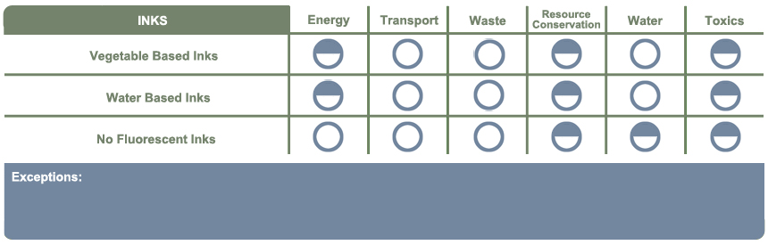
Ink Purchasing Guide

1. The environmentally-preferred product is not available at a competitive price
2. The environmentally-preferred product is not available within a reasonable time frame
3. The environmentally-preferred product does not meet appropriate performance standards
3. The environmentally-preferred product does not meet appropriate performance standards as determined by Your organization.

Definition of Terms
- Vegetable Based Inks are generally considered to be biodegradable because they are made with renewable resources such as soy, linseed, cottonseed, tung, or china wood oil. They have low volatile organic compound content, greatly decreasing the exposure to air borne chemical pollutants.
- Water Based Inks are similar to conventional inks and do not contain or a very low amount of volatile organic compounds.
- Metallic and/or Fluorescent Inks are, in general, more toxic because they contain heavy metals. Although some materials printed with metallic ink may be recycled, they do not decompose easily, and the heavy metal components can be hazardous to human health if they get into surface or groundwater.

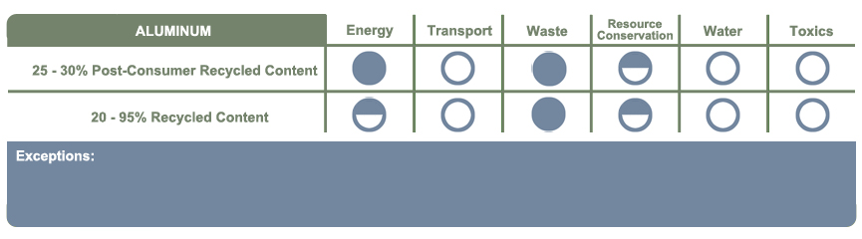
Aluminum Purchasing Guide

1. The environmentally-preferred product is not available at a competitive price
2. The environmentally-preferred product is not available within a reasonable time frame
3. The environmentally-preferred product does not meet appropriate performance standards

Definition of Terms
- Post-Consumer Recycled Content Aluminum contains aluminum that has been used in soda cans and other applications before and has been recycled into new aluminum products. Post-consumer recycled aluminum is considered the most environmentally friendly because it has been used at least once before and alleviates a lot of the mining and transportation impacts associated with virgin aluminum.
- Recycled Content Aluminum contains recycled aluminum from pre and postindustrial sources, but the aluminum has not been previously used. The aluminum typically comes from excess metal scraps from the factory, including virgin content.

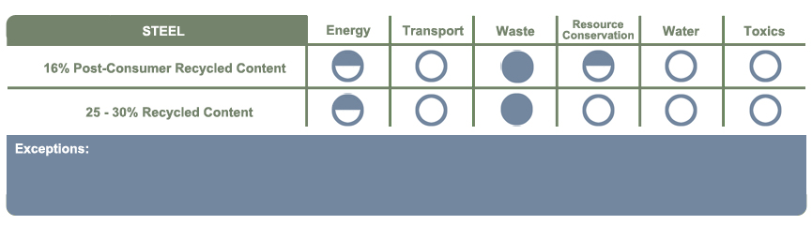
Steel Purchasing Guide

1. The environmentally-preferred product is not available at a competitive price
2. The environmentally-preferred product is not available within a reasonable time frame
3. The environmentally-preferred product does not meet appropriate performance standards
Definition of Terms
- Post-Consumer Recycled Content Steel contains steel that has been used in other applications before and has been recycled into new steel. Steel can be recycled almost indefinitely and can be easily recycled for other applications, reducing environmental impacts from mining and manufacturing new steel.
- Recycled Content Steel contains recycled steel from pre and postindustrial sources, but the steel has not been previously used. The steel typically comes from excess metal scraps from the factory, including virgin content.

